Dichotomy.
We are speaking about a specific type a dichotomy. The the of dichotomy who deal with a whole.
You have a system formed of two components but yet indissociable like two side of a coin of the two side of a plan.


The first operation that a dichotomy must do is to re-organize the plan. Organization that slide half of a side to the other side of the plan.
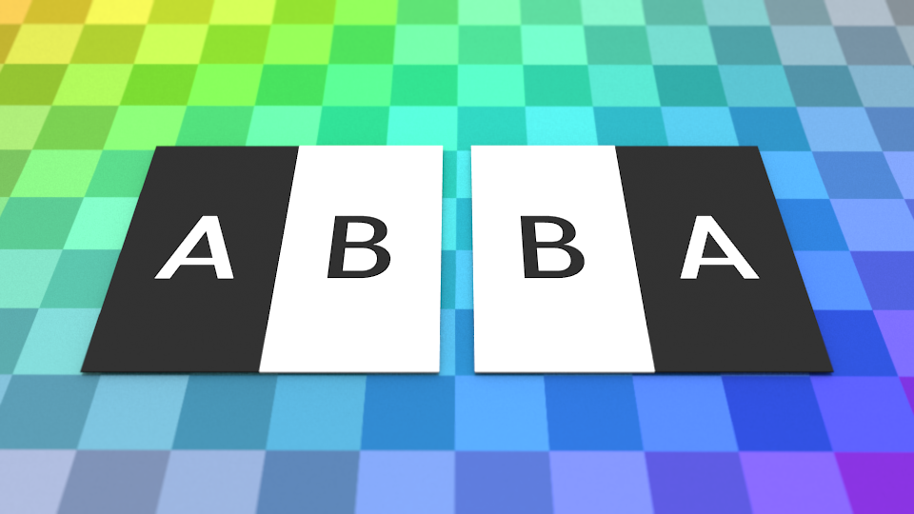
After that cutting is a child play. But you also get only of the original surface.

But a dichotomy is not about cutting in half. It's about determining which side is the true one. As when you have a duality you have to define which one is the primary against the other one. The operation to show the arbitrariness of these choose is the Derrida's deconstruction.
So instead of cutting it's a folding operation. Where one side if fold against the other. The first side becoming the primary or the truth the other side a mere consequences of the truth.


But what doesn't this operation mean regarding the knowledge you can get from this operation?
Half knowledge.
No system based on a dichotomy can pretend to explain all. As a dichotomy can only know half.

The unknown part is itself divided in half, one half is cover by a paradoxical explanation which is an extrapolation, the other half stay unknown for ever.

The paradoxical explanation is again itself cut in half, the paradoxical true, true from the view point of the dichotomy inverses. And the paradoxical false, but consistent with the current dichotomy.

It's on the paradoxical false that we found the original tautology, the original tautology can be multiple in its form. The original tautology is the fundamental myth, the original fold who use its own presence to justify itself.
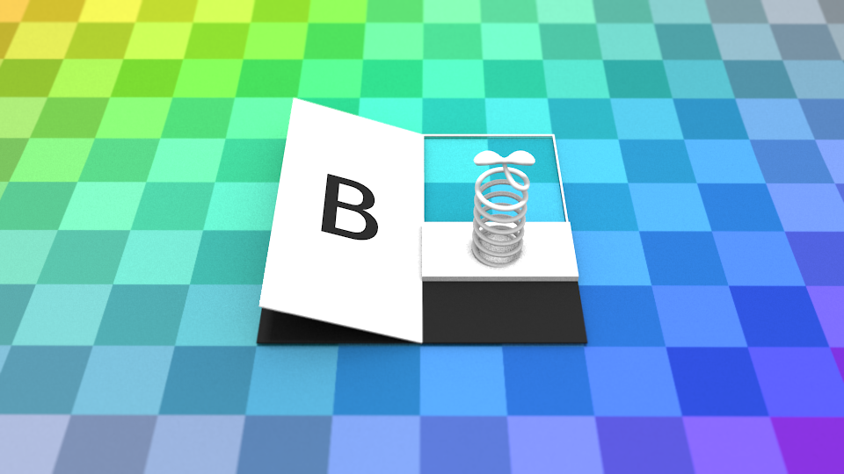
But it's in the missing part of this tautology that you can find the trace of the inversed dichotomy. This original dichotomy code and decode every knowledge on this side of the dichotomy.
AB: We are difference because I invoke the difference and by invoking difference I establish difference.
BA: We are semblable because I invoke the semblance and by invoking semblance I establish semblance.
What is missing in AB is semblance and in BA is difference.
But to have difference you need to have semblance to have semblance you need to have difference.

